Bahria University,

Karachi Campus



LAB EXPERIMENT NO.

10

LIST OF TASKS

|  |  |
| --- | --- |
| TASK NO | OBJECTIVE |
| 1 | **An automotive company wants to identify and treat outliers in their "mtcars" dataset, which contains information about various car models. They suspect that certain car models might have outlier values in certain variables and want to analyze and handle them using Python. Perform the following outlier detection techniques.**   1. **Box Plot** 2. **Z-score** 3. **IQR range**   **Scatter plot** |
| 2 | **An automotive company has identified outliers in their "mtcars" dataset and wants to treat them to ensure accurate analysis and modeling. They want to handle the outliers using Python. Performed the techniques that provided in the lab to treat the outliers.** |

Task 1: **An automotive company wants to identify and treat outliers in their "mtcars" dataset, which contains information about various car models. They suspect that certain car models might have outlier values in certain variables and want to analyze and handle them using Python. Perform the following outlier detection techniques.**

1. **Box Plot**
2. **Z-score**
3. **IQR range**

**Scatter plot**

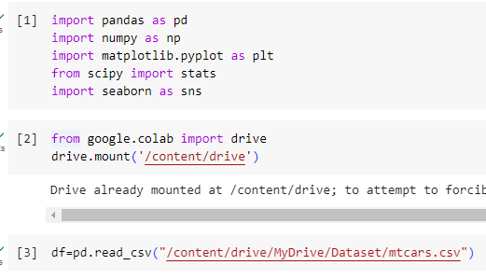

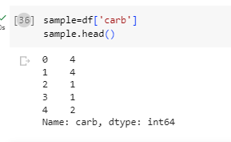

**Task 2: An automotive company has identified outliers in their "mtcars" dataset and wants to treat them to ensure accurate analysis and modeling. They want to handle the outliers using Python. Performed the techniques that provided in the lab to treat the outliers.**

